SIMATS ENGINEERING
ASSESSMENT TOOL 1

COURSE CODE: MLA03
COURSE NAME: Reinforcement learning for Environment and Agent

COURSE OUTCOME COVERED

CO2: Apply Dynamic Programming methods to solve reinforcement learning problems and derive optimal policies for decision-making tasks. (BL2, BL3)

Assessment Tool Weightage: 35%

Dr DUMPALA PRASANTH

QUESTIONS: 10 Total Marks: 50

Annexure A

Industry Problem Task Duration: 2.5hrs

1. Explain how Reinforcement Learning can be applied to optimize delivery routes in a logistics system. Identify the possible states, actions, rewards, and policy. Discuss how continuous learning improves efficiency over time. (5 Marks)

2. Apply Reinforcement Learning concepts to a fraud detection system in fintech. Define the state space, action space, and reward mechanism. Explain how exploration strategies improve detection accuracy. (5 Marks)

3. Illustrate how Reinforcement Learning is used in a streaming platform for content recommendation. Discuss the impact of delayed rewards, user feedback, and changing preferences on learning performance. (5 Marks)

4. Evaluate the effectiveness of Reinforcement Learning in predictive maintenance compared to traditional rule-based approaches. Discuss risks and reliability concerns in industrial environments. (5 Marks)

5. Analyze how Reinforcement Learning can be used to optimize transportation systems such as bus scheduling or route allocation. Define states, actions, and rewards, and discuss how real-time data improves performance. (5 Marks)

6. Apply Reinforcement Learning to dynamic pricing in e-commerce. Define the state space, action space, and reward function. Discuss challenges in balancing exploration and exploitation. (5 Marks)

7. Illustrate the use of Reinforcement Learning in smart city waste management systems. Identify the MDP components and discuss how continuous updates improve operational efficiency. (5 Marks)

8. Evaluate how Reinforcement Learning can be used in network bandwidth allocation in telecommunications. Define states, actions, and rewards, and examine how the system adapts to dynamic conditions. (5 Marks)

9. Analyze the application of Reinforcement Learning in portfolio management in finance. Discuss advantages over traditional models and challenges such as risk and delayed rewards. (5 Marks)

10. Justify the use of Reinforcement Learning in renewable energy management systems. Define the RL framework components and discuss the impact of environmental uncertainty on decision-making. (5 Marks)

Code of Conduct:

I _Ch. Harsha Chakravarthi (19245095)_ (Name / Reg No) certify that this submission is my original work and that I have adhered to the guidelines specified for this assessment.
I understand that any violation of academic integrity rules will result in disciplinary action.

Signature of the student:

RUBRICS FOR CALCULATION

Criteria | Weightage | Level 4 – Exemplary | Level 3 – Proficient | Level 2 – Developing | Level 1 – Beginning
Criteria | Weightage | Level 4 – Exemplary | Level 3 – Proficient | Level 2 – Developing | Level 1 – Beginning
Understanding of Industry Problem | 20% | Comprehensive understanding of real-world problem and constraints | Good understanding with minor gaps in requirements | Basic understanding; some requirements unclear | Poor understanding; misinterprets problem context
Application of Engineering Concepts | 25% | Applies advanced and relevant concepts effectively to solve the problem | Applies appropriate concepts with minor errors | Limited application of concepts | Incorrect or no application of concepts
Solution Design | 25% | Innovative, practical, and feasible solution aligned with industry standards | Logical and feasible solution with minor gaps | Basic solution with limited feasibility | Unclear or impractical solution
Use of Tools | 15% | Effective use of modern tools, technologies, and real data | Appropriate use of tools with correct implementation | Limited or inconsistent use of tools | Minimal or incorrect use of tools
Analysis | 10% | Thorough analysis with validated results and performance evaluation | Good analysis with reasonable validation | Basic analysis with limited validation | Poor or no analysis
Professionalism | 5% | Highly professional, well-documented, and clearly presented work | Good documentation and presentation | Basic documentation with some gaps | Poor documentation and presentation

Q1. Reinforcement Learning for Optimizing Delivery Routes in Logistics
Reinforcement Learning (RL) frames route optimization as a sequential decision-making problem in which a delivery agent (vehicle or routing engine) learns, through repeated trial and feedback, which routing decisions minimize cost, time, and fuel consumption across a dynamic road network. This differs fundamentally from classical shortest-path algorithms (e.g., Dijkstra) because the agent optimizes for long-run cumulative performance across many deliveries and many days, not a single static shortest path.
MDP Formulation
- States (S): current vehicle location, remaining delivery stops, time of day, traffic density, vehicle load/capacity, and weather conditions.
- Actions (A): choice of next road segment/junction to traverse, choice of next customer stop to serve, or decision to reroute around congestion.
- Rewards (R): negative reward for distance/time/fuel consumed and for late deliveries; positive reward for on-time or early completion and for minimizing total route length.
- Policy (π): a mapping from the current state (location, remaining stops, traffic) to the next best action, learned so as to maximize expected cumulative (discounted) reward over the full delivery run.
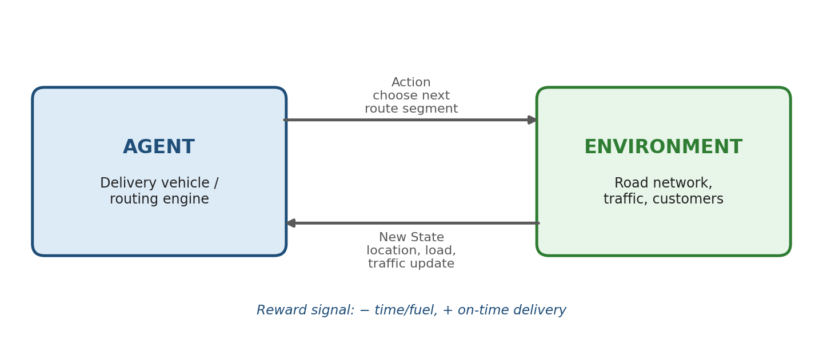
Agent–environment interaction loop for RL-based route optimization
Algorithmic Approach
Such problems are commonly solved as a variant of the vehicle routing problem (VRP) using Deep Q-Networks (DQN) or policy-gradient methods (e.g., PPO), often combined with graph neural networks to represent the road network. The agent is typically pre-trained in a simulated environment (a digital twin of the delivery network) before being deployed on live routes, which limits the cost of early, poorly performing exploratory actions.
Continuous Learning and Efficiency
Because traffic, demand, and road conditions change daily, the agent is retrained or updated online using real-time GPS and traffic-feed data. Techniques such as Q-learning or policy-gradient methods allow the policy to be refined after every delivery cycle, so the system gradually learns to avoid recurring congestion points, better sequence multi-stop deliveries, and adapt to seasonal demand shifts. Companies such as large parcel carriers have reported measurable reductions in distance travelled after adopting adaptive, learning-based routing over static, rule-based systems, since the policy keeps improving as more delivery data accumulates rather than remaining fixed.

Q2. Reinforcement Learning for Fraud Detection in Fintech
In a fintech fraud-detection system, RL treats the detection engine as an agent that decides, transaction by transaction, whether to flag, allow, or escalate a transaction for manual review, learning from the outcomes of its decisions rather than from a fixed labeled dataset alone. This is valuable because fraud is inherently adversarial and non-stationary: fraudsters actively change their tactics to evade whatever static rule or classifier is currently deployed, so a system that only learns once from historical data quickly becomes outdated.
MDP Formulation
- State space (S): transaction features such as amount, merchant category, location, device fingerprint, transaction velocity, account history, and behavioral deviation from the user's typical pattern.
- Action space (A): approve the transaction, decline it, flag it for manual review, or request additional authentication (e.g., OTP/step-up verification).
- Reward mechanism (R): a large positive reward for correctly blocking genuine fraud, a large negative reward (penalty) for a false decline that inconveniences a legitimate customer, and a smaller negative reward for missed fraud (false negative) discovered later through chargebacks.
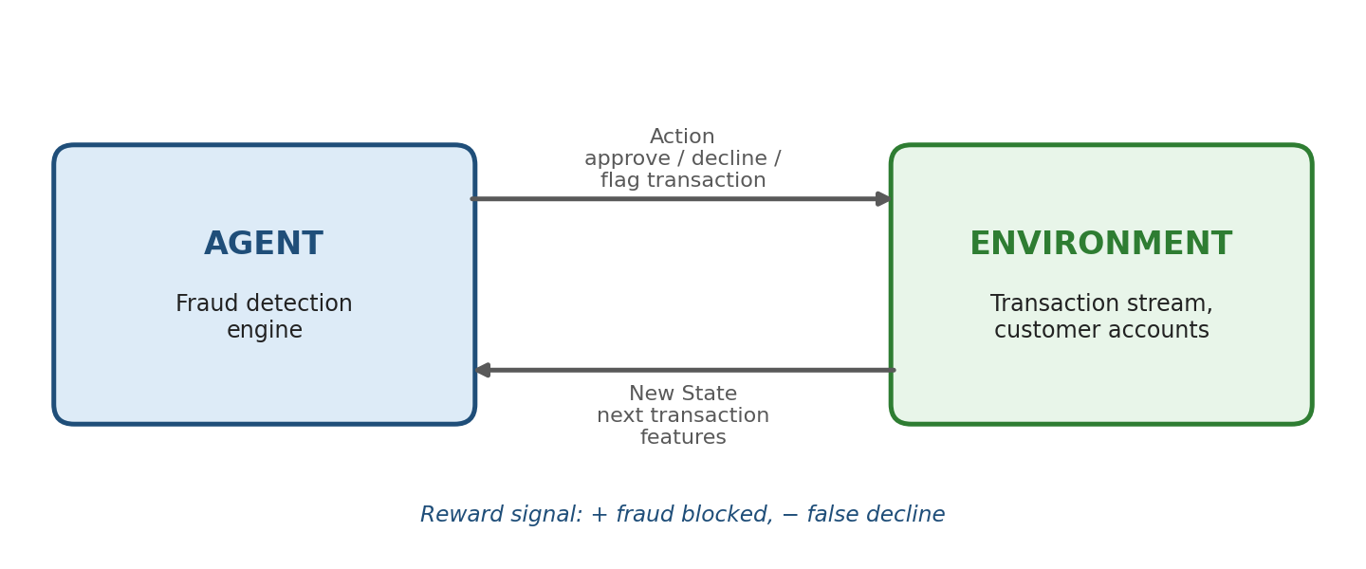
Agent–environment interaction loop for RL-based fraud detection
Exploration and Detection Accuracy
Because fraud patterns evolve as criminals adapt, the agent cannot rely purely on exploiting previously learned patterns. Exploration strategies such as epsilon-greedy or upper-confidence-bound (UCB) sampling deliberately test borderline or novel transaction patterns instead of always taking the "safe" known action. This lets the system discover new fraud signatures and adapt its policy before losses accumulate, while exploitation continues to apply the already-learned high-confidence rules for known fraud types.
Practical Considerations
Class imbalance is a major challenge, since genuine fraud events are rare relative to legitimate transactions, so reward shaping and cost-sensitive learning are used to prevent the agent from trivially learning to "always approve." Combining RL with an offline-trained supervised anomaly detector as an initial policy (a warm start) is common practice, letting the RL layer fine-tune decision thresholds and escalation behavior on live data while reducing the risk of costly early exploration mistakes.

Q3. Reinforcement Learning for Content Recommendation on Streaming Platforms
A streaming platform's recommendation engine can be modeled as an RL agent that selects which content to display or recommend to a user in order to maximize long-term engagement, rather than just the click probability of a single recommendation. This shifts the objective from myopic click-through optimization (as in classical collaborative filtering) to a sequential objective: keeping the user satisfied and subscribed across many sessions.
MDP View
- State: user's viewing history, current session context (device, time of day), genre preferences, and recent interaction signals.
- Action: which title, thumbnail, or ranked list of content to present next.
- Reward: watch time, completion rate, likes/ratings, and subscription retention; skipped or abandoned content yields low or negative reward.
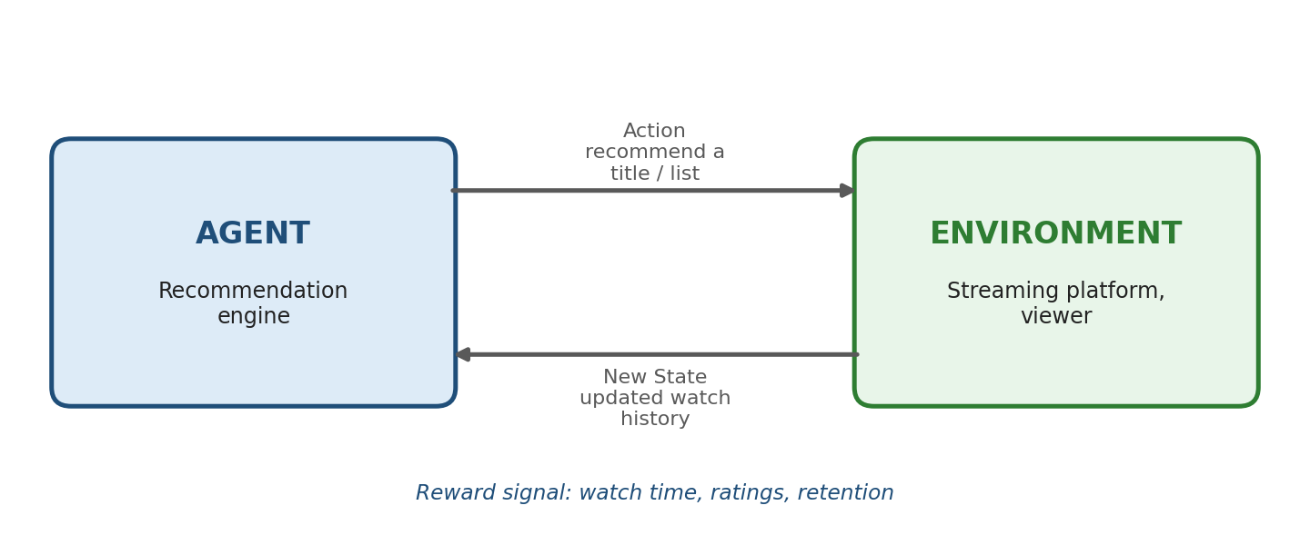
Agent–environment interaction loop for RL-based content recommendation
Effect of Delayed Rewards
The true value of a recommendation (e.g., whether it keeps a user subscribed) is often only observable weeks later, so the agent must use temporal-difference learning or long-horizon discounted returns rather than immediate click-through reward alone, which can mislead the policy toward clickbait-like content that maximizes short-term clicks but harms long-term satisfaction.
User Feedback and Changing Preferences
Explicit feedback (ratings, thumbs up/down) and implicit feedback (watch/skip behavior, rewatches, scroll-past events) continuously update the state representation. Because tastes drift over time (a non-stationary environment) and are influenced by seasonal or trend-driven factors, the policy must keep exploring new content categories (contextual bandit-style exploration is common in production systems), and models are periodically retrained so recommendations do not overfit to stale preferences, keeping recommendation quality aligned with the user's current interests.

Q4. RL vs Rule-Based Approaches in Predictive Maintenance
Effectiveness of RL
In predictive maintenance, an RL agent observes sensor telemetry (vibration, temperature, pressure, run-hours) as its state and chooses actions such as continue operation, schedule maintenance now, or replace a component, receiving rewards that balance the cost of unplanned downtime against the cost of unnecessary maintenance. Unlike static rule-based systems that trigger maintenance purely on fixed thresholds (e.g., "service every 500 hours"), RL learns condition-based, adaptive thresholds tailored to each machine's actual degradation pattern, which typically reduces both unnecessary maintenance and unexpected failures, improving overall equipment effectiveness (OEE).
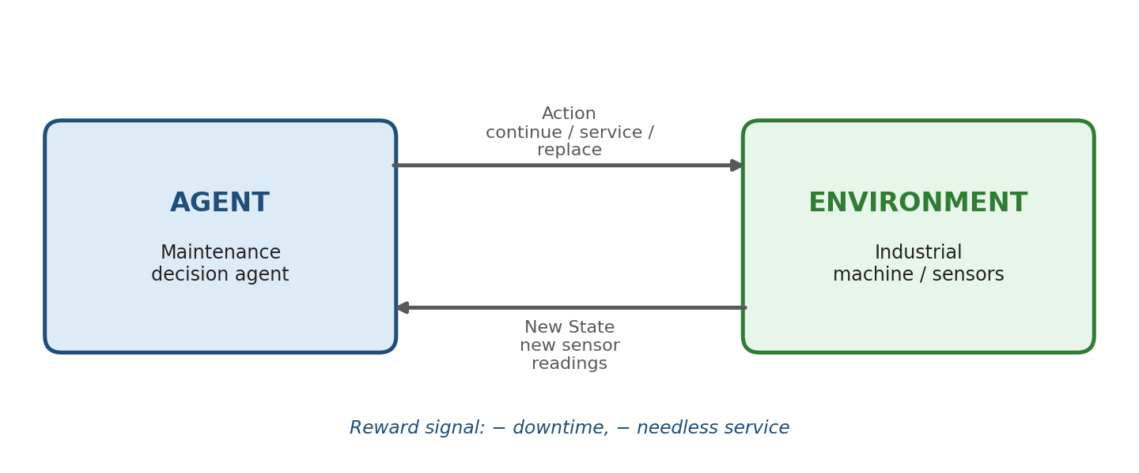
Agent–environment interaction loop for RL-based predictive maintenance
Comparison with Rule-Based Approaches
- Rule-based systems are transparent and easy to audit but cannot adapt to equipment-specific wear patterns or changing operating conditions; every machine is treated identically regardless of its actual health.
- RL policies adapt continuously from real operating data, generally achieving lower total cost (downtime + maintenance) but requiring far more historical/simulated data to train reliably, plus careful reward design to reflect true business cost trade-offs.
- Hybrid approaches, where RL operates within safety envelopes defined by rule-based guardrails, are increasingly used in practice to gain adaptability without sacrificing baseline safety guarantees.
Risks and Reliability Concerns
- Exploration risk: trying a "wait and see" action on real industrial equipment can cause costly or unsafe failures, so training often needs a digital twin/simulator before deployment.
- Black-box decisions: RL policies are harder to interpret than fixed rules, complicating safety certification, regulatory approval, and operator trust.
- Data and reward-design risk: a poorly designed reward function may lead the agent to under-prioritize rare but catastrophic failure modes, since such events appear infrequently in training data.

Q5. RL for Optimizing Public Transportation Systems
Reinforcement Learning can optimize bus scheduling and route allocation by treating the transit control system as an agent that continuously decides dispatch times, headways, and route assignments to minimize passenger wait time and operating cost. This is particularly valuable in cities where demand is highly variable by time of day and route, and where a single static timetable cannot serve all conditions efficiently.
MDP Formulation
- States: current bus locations, passenger demand at each stop, time of day, traffic congestion, and existing schedule adherence/delay.
- Actions: dispatch a bus now or hold it, reroute a bus to a higher-demand corridor, or adjust the headway (interval) between buses.
- Rewards: negative reward for passenger waiting time and bus bunching/overcrowding; positive reward for schedule adherence, even passenger distribution, and fuel/operational efficiency.
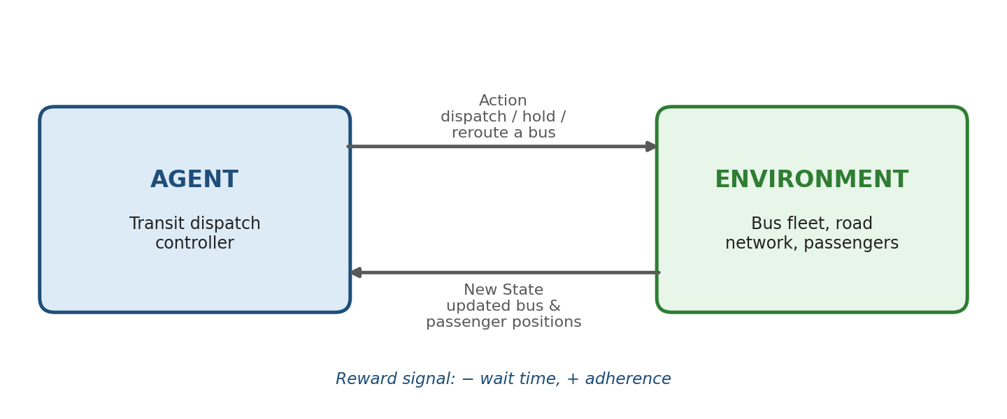
Agent–environment interaction loop for RL-based transit scheduling
Role of Real-Time Data
Live GPS feeds, ticketing/ridership data, and traffic APIs continuously update the state, allowing the policy to react to real-time disruptions (accidents, special events) rather than following a fixed timetable. Multi-agent RL formulations, where each bus is treated as a cooperating agent, are often used so that the fleet as a whole avoids bunching (several buses arriving together) while still maximizing coverage. Over repeated service days, the agent learns demand patterns by time and location (e.g., rush-hour surges near business districts), progressively reducing average wait times, bus bunching, and empty-running distance compared with fixed, non-adaptive schedules.

Q6. Reinforcement Learning for Dynamic Pricing in E-Commerce
Dynamic pricing can be modeled as an RL problem where the pricing engine is an agent that sets a product's price in each period to maximize long-run revenue or profit while remaining competitive. Unlike static or rule-based pricing (e.g., cost-plus-margin pricing), RL allows the price to respond to real-time shifts in demand, competitor behavior, and inventory pressure.
MDP Formulation
- State space: current inventory level, competitor prices, demand trend, seasonality, customer segment, and time remaining in a sales cycle.
- Action space: the discrete or continuous price point to set (e.g., a percentage markup/markdown) for the next time interval.
- Reward function: realized profit/revenue in that period, with penalties for excess unsold inventory (holding cost) or for prices that trigger a sharp drop in conversion rate.
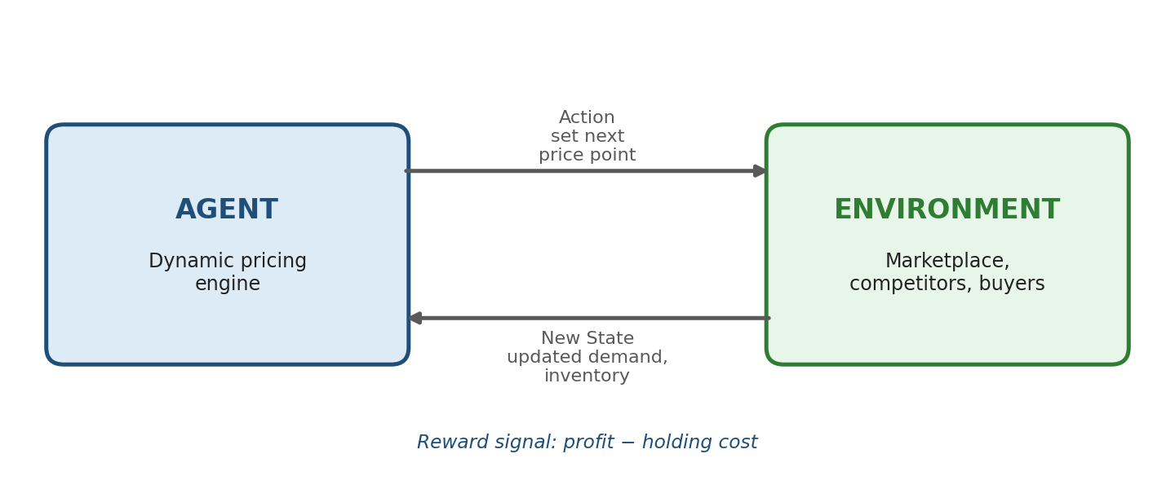
Agent–environment interaction loop for RL-based dynamic pricing
Exploration vs Exploitation Challenge
Exploiting the currently known best price maximizes short-term revenue but risks missing a better price point as demand or competitor behavior shifts, while exploring new price points (e.g., via Thompson sampling or bandit-style exploration) risks short-term revenue loss and possible customer dissatisfaction if prices fluctuate visibly. Balancing this trade-off, often by constraining how much and how often prices can change (price-change smoothing), is central to making RL-based dynamic pricing both profitable and customer-acceptable, while also avoiding reputational or regulatory concerns around perceived price discrimination.

Q7. Reinforcement Learning in Smart City Waste Management
In a smart waste-management system, RL can optimize bin collection routes and schedules by learning from real-time fill-level sensor data instead of following a fixed collection calendar. This addresses two common inefficiencies of traditional fixed-schedule collection: bins that overflow between scheduled visits, and trucks that make wasted trips to bins that are still mostly empty.
MDP Components
- States: fill levels of bins across the city, truck locations and remaining capacity, traffic conditions, and time since last collection per zone.
- Actions: which bin/zone to collect next, or whether to defer collection of a partially full bin.
- Rewards: positive reward for collecting near-full bins efficiently (short routes, low fuel use) and negative reward for overflow events, wasted trips to near-empty bins, or excessive truck idle time.
- Transition dynamics: bin fill levels evolve stochastically based on local waste generation patterns (residential vs commercial zones, day of week, local events).
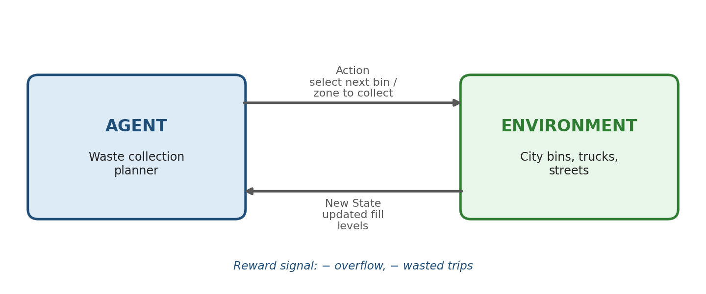
Agent–environment interaction loop for RL-based waste collection
Continuous Updates and Efficiency
As sensor (IoT) data streams in continuously, the agent's policy is updated so collection routes shift dynamically toward zones filling up faster (e.g., commercial districts on weekends), reducing both overflow incidents and unnecessary collection trips. Over successive weeks the system learns city-wide waste-generation rhythms, improving fuel efficiency, lowering carbon emissions from truck traffic, and reducing operating cost compared with fixed-route collection.

Q8. RL for Network Bandwidth Allocation in Telecommunications
Bandwidth allocation across users, applications, or network slices can be treated as an RL control problem where the network scheduler is the agent adjusting resource allocation to maximize throughput and fairness under fluctuating demand. This is especially relevant in 5G/6G networks with network slicing, where multiple service types (voice, video, IoT) compete for shared spectrum with very different latency and reliability requirements.
MDP Formulation
- States: current traffic load per link/user, queue lengths, latency/jitter measurements, and application priority class (voice, video, data).
- Actions: how much bandwidth or how many time-frequency resource blocks to allocate to each user or slice in the next scheduling interval.
- Rewards: positive reward for high aggregate throughput, low latency, and fairness across users; negative reward for packet loss, congestion, or violation of service-level agreements (SLAs).
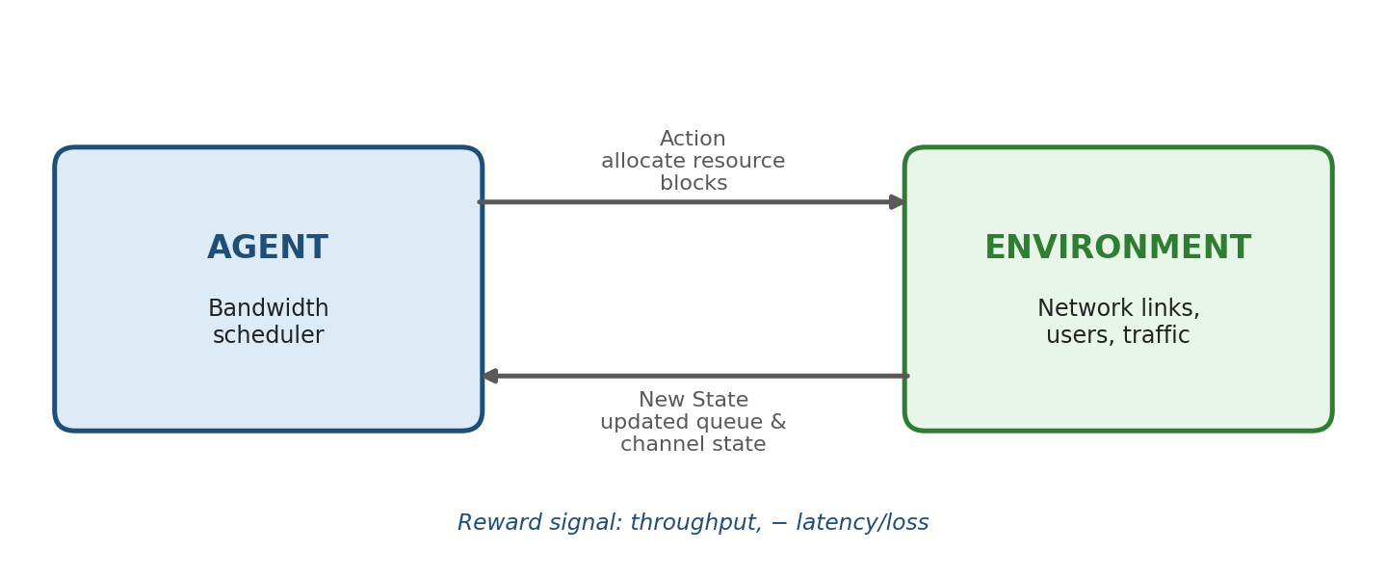
Agent–environment interaction loop for RL-based bandwidth allocation
Adapting to Dynamic Conditions
Because traffic demand and channel conditions (e.g., wireless interference, user mobility) change on the order of milliseconds to minutes, the RL policy is retrained or fine-tuned continuously using online learning, allowing it to reallocate bandwidth in real time — for example, prioritizing latency-sensitive video calls during a congestion spike, then reverting when load drops. This adaptive behavior generally outperforms static allocation schemes, which cannot respond to sudden demand surges or changing user priorities, and can also reduce energy consumption at base stations by avoiding over-provisioning of unused capacity.

Q9. Reinforcement Learning in Portfolio Management
Portfolio management can be formulated as an RL problem where the agent (the trading/allocation policy) decides how to distribute capital across assets at each time step to maximize long-term risk-adjusted return. This is naturally sequential: every allocation decision affects the portfolio's starting position for the next period, which is exactly the structure an MDP is designed to capture.
Formulation
- State: current portfolio weights, historical price/return data, volatility indicators, and macroeconomic signals.
- Action: rebalancing decision — the new allocation weights across the available assets (buy, sell, hold proportions).
- Reward: portfolio return over the period, often adjusted for risk (e.g., using a Sharpe-ratio-based reward) and penalized for excessive transaction costs.
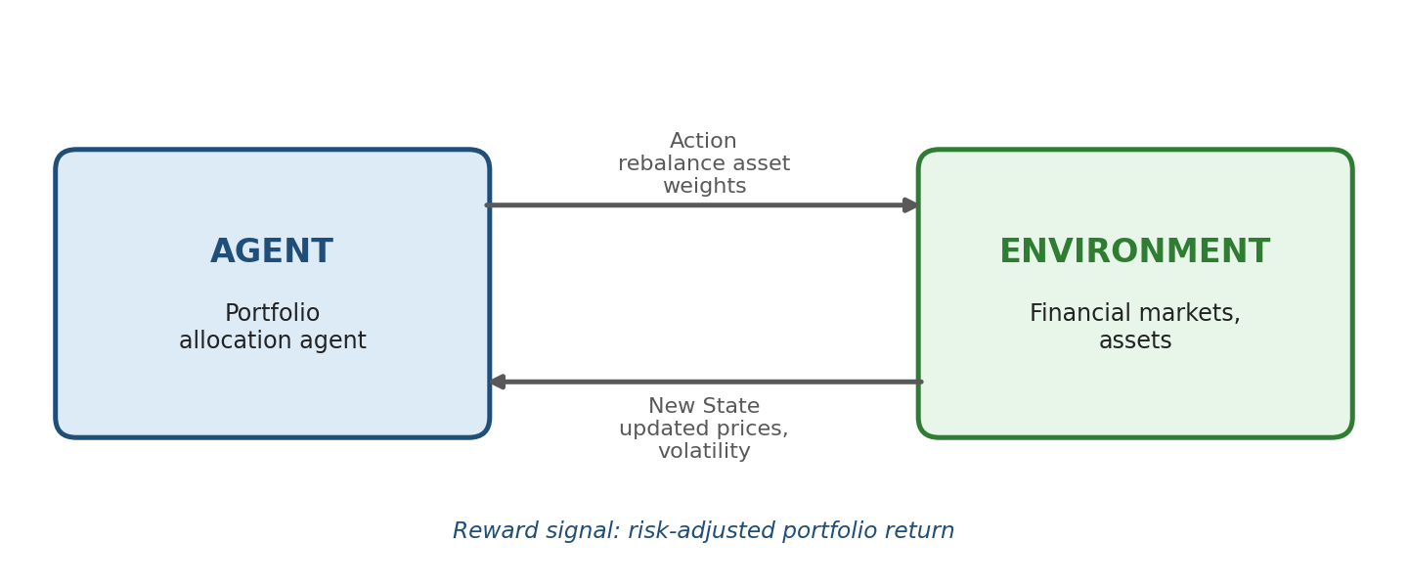
Agent–environment interaction loop for RL-based portfolio management
Advantages over Traditional Models
Classical models such as Mean-Variance Optimization (Markowitz) rely on static, often unrealistic assumptions (normally distributed returns, fixed correlations) that are re-estimated periodically. RL instead learns an adaptive policy directly from sequential market data, allowing it to react to changing volatility regimes and non-linear market dynamics without needing an explicit, hand-specified model of asset returns, and it can naturally incorporate transaction costs and constraints directly into the reward function.
Challenges
- Financial markets are highly non-stationary, so a policy trained on historical data may not generalize to future regimes (regime shifts, crises).
- Delayed and noisy rewards make it hard for the agent to attribute a return to a specific earlier action (the credit assignment problem).
- Risk of overfitting to historical patterns and amplifying losses during rare, extreme market events (tail risk), which is why risk-aware reward shaping and stress-testing in simulation are essential before live deployment.

Q10. Justifying Reinforcement Learning for Renewable Energy Management
Renewable energy systems (solar, wind, battery storage, grid demand) are highly variable and only partially predictable, which makes RL well suited compared with fixed rule-based energy dispatch, since the agent can learn an adaptive policy directly from operating experience rather than relying on static forecasts that quickly become outdated as weather and demand shift.
RL Framework Components
- State: current renewable generation output, battery state of charge, grid demand/load forecast, electricity price, and weather conditions.
- Action: how much energy to store, discharge, sell to the grid, or curtail generation at the current time step.
- Reward: economic value gained (revenue from sold energy, cost savings from self-consumption) minus penalties for unmet demand, battery degradation from excessive cycling, or curtailment of usable renewable energy.
- Policy: a mapping from current grid/weather/storage state to the optimal energy dispatch action, learned to maximize long-term cumulative reward.
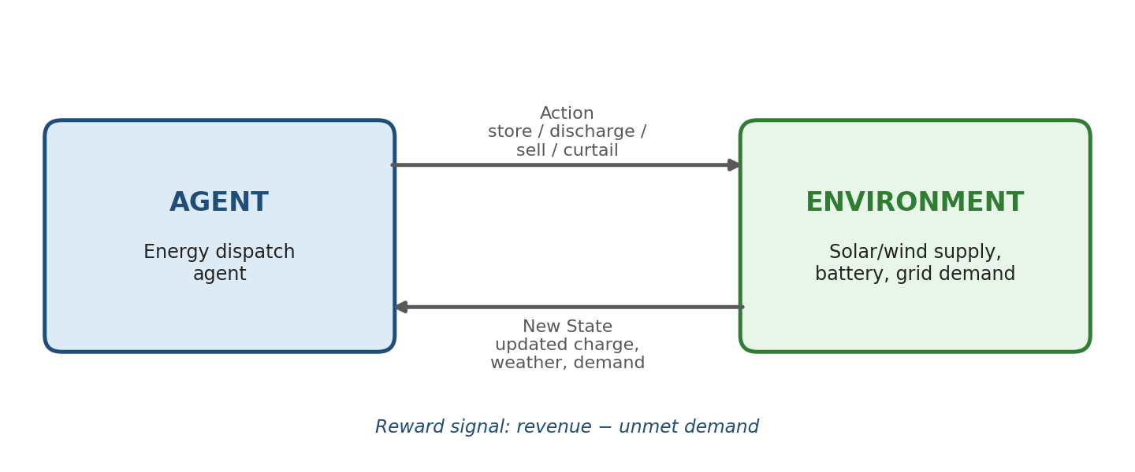
Agent–environment interaction loop for RL-based renewable energy dispatch
Justification and Impact of Environmental Uncertainty
Because solar irradiance and wind speed are stochastic and only imperfectly forecastable, a fixed dispatch schedule is systematically suboptimal; RL policies instead learn to hedge against this uncertainty, for example by learning to store energy more conservatively before forecast-uncertain periods and discharge more aggressively when generation is reliably high. This continuous adaptation to environmental uncertainty improves grid stability, reduces reliance on fossil-fuel backup generation, extends battery lifetime by learning gentler charge/discharge cycles, and increases the overall utilization of renewable capacity compared with static, rule-based control.

